CSIS 4495 - Applied Research Project
CSIS 4495 - Applied Research Project | 1
Written Project Plan Proposal and Contract Review | 2
1.0 Title Page | 2
2.0 Introduction | 3
2.1 Domain Overview and Background | 3
2.2 Problem Framing | 3
2.3 Literature and Research Summary | 4
2.4 Hypotheses and Assumptions | 4
2.5 Potential Benefit | 4
3.0 Proposed Research Project | 5
3.1 Research Design and Objectives | 5
3.2 Core Application Modules (New) | 5
3.3 Methodology and Justification | 6
3.4 Data Analysis Plan (Revised) | 6
3.5 Technologies | 7
3.6 Expected Results | 7
3.7 Riipen External Partners or affiliates | 7
4.0 Project Planning and Timeline | 7
5.0 Project Contract | 9
6.0 Work Logs for Student | 9
7.0 Closing and References | 10
7.1 Acknowledgements | 10
7.2 References | 10

Written Project Plan Proposal and Contract Review

1.0 Title Page
Project Title: Fooditude: A Community-Driven Mobile Web Application for Hyper-Local Food Waste Reduction
Team Member:
- Frederick K. Okornoe - Project Lead
  - Student ID: 300373397
Course and Section: CSIS 4495 - Applied Research Project, Section 001

2.0 Introduction

2.1 Domain Overview and Background
Food waste is a significant global challenge with far-reaching environmental, economic, and social consequences. According to the Food and Agriculture Organization of the United Nations, approximately one-third of all food produced for human consumption is lost or wasted globally, amounting to 1.3 billion tons per year. This waste contributes significantly to greenhouse gas emissions, squanders resources like water and land, and represents a missed opportunity to address food insecurity. While large-scale initiatives exist to connect commercial food surpluses with food banks, a substantial portion of waste occurs at the household level, which is often unaddressed by centralized solutions.

2.2 Problem Framing
The central problem this research aims to address is the lack of a user-friendly, community-centric, and scalable solution for managing and redistributing household food surpluses. Individuals frequently find themselves with excess food whether from over-purchasing, travel, or garden abundance that they are unable to consume before it spoils. Currently, there is no organized and convenient mechanism for these individuals to connect with others in their immediate community who could use the food. This results in unnecessary waste and perpetuates a disconnect between food surplus and food insecurity at a hyper-local level. This project proposes to develop a mobile-responsive web application (Fooditude) to bridge this gap by enabling direct, peer-to-peer exchange of surplus food within defined neighbourhoods.

2.3 Literature and Research Summary
Existing research and platforms have explored various approaches to food waste. Commercial apps like "Too Good To Go" focus on connecting consumers with restaurant and retail food surpluses. While effective, these models do not address the substantial volume of waste originating from individual households. Local food banks and pantries are critical, but their operational models are often centralized and rely on large donations, making them less accessible for small-scale household sharing. This research aims to bridge this gap by creating a platform that leverages the principles of the sharing economy and social networking to empower individuals to be part of the solution directly. This approach is supported by emerging research on the role of digital platforms in fostering pro-social and sustainable behaviours within small communities, specifically focusing on building trust through digital validation (e.g., user ratings and transparent profiles).

2.4 Hypotheses and Assumptions
The primary hypothesis is that a user-friendly, community-driven digital platform will significantly increase the rate of successful food sharing and subsequently reduce household food waste within a defined community by making the exchange process convenient and reliable.
It is assumed that:
- Individuals are willing to share their surplus food if the process is simple and convenient.
- A system for building trust and accountability (e.g., through user ratings) is essential for platform adoption and sustained use.
- A local network effect will take hold, where increased participation will make the platform more valuable for all users, leading to a self-sustaining cycle of waste reduction.

2.5 Potential Benefit
The development of this platform has the potential for a direct and measurable positive impact. By facilitating the exchange of surplus food, it will contribute to a more sustainable local food system, reduce environmental impact, and enhance food security by making food more accessible to those in need. Furthermore, the platform will foster a stronger sense of community and social cohesion by encouraging residents to interact and collaborate on a shared goal. The resulting functional prototype and research findings will provide a practical, open-source model that can be replicated in other communities globally.

3.0 Proposed Research Project

3.1 Research Design and Objectives
The research design is an applied research project, focusing on the development and validation of a functional prototype, Fooditude. The project will follow a phased approach: Development, Pilot Implementation, and Evaluation.
The core objectives are to:
- Design and Develop: Create a minimalist, intuitive, and mobile-responsive web application that includes essential modules for listing, claiming, and facilitating communication between users.
- Pilot Study: Launch the functional prototype in a small, targeted community (e.g., a specific neighbourhood/apartment building) to test its usability and functionality.
- Data Collection and Analysis: Monitor platform usage metrics (quantitative data) and collect qualitative data through user surveys to assess the platform's effectiveness and user satisfaction, explicitly measuring the platform's impact on sharing behaviour.

3.2 Core Application Modules
The functional prototype will include the following essential modules to ensure a complete and measurable user experience:
Module | Features | Purpose
User Profile & Trust | User authentication, profile creation, display of rating/review history. | To establish accountability and build community trust, which is critical for food sharing.
Food Listing | Form input for item name, description, photo upload, quantity, "best before" date, and defined pickup location type. | To enable quick, accurate, and transparent listing of surplus food items.
Discovery & Search | List view of available food items, with filtering by proximity/location, item type, and date posted. | To allow users to efficiently find available food items in their immediate area.
Claiming & Reservation | A dedicated button to "Claim" an item. Item visibility is immediately toggled upon claiming. | To prevent double-claiming and manage inventory effectively in real-time.
In-App Messaging | Direct, secure chat feature between the lister and the claimant. | To facilitate coordination of specific pickup times and any necessary instructions without sharing personal contact information.

3.3 Methodology and Justification
This project will follow an Agile development methodology, allowing for continuous feedback loops and iterative improvements based on pilot study data. The justification for this approach lies in the need to quickly validate core assumptions about user behaviour in the sharing economy, allowing for fast pivoting based on early user feedback before final reporting.

3.4 Data Analysis Plan
Data will be collected from two primary sources: platform usage analytics (quantitative) and participant surveys (qualitative).
Quantitative Analysis (Platform Usage Metrics):
- Data Source: Firestore event logs and collected item metadata (e.g., time of post, time of claim).
- Methodology: Descriptive Statistical Analysis will be used to calculate Key Performance Indicators (KPIs) to objectively measure adoption and usage efficiency.
- Key Metrics:
  - Claim Rate: The percentage of listed items that are successfully claimed.
  - Time-to-Claim: The average time (in hours) between an item being listed and being claimed. This measures platform efficiency.
  - Active Users: The number of unique users who complete at least one transaction (list or claim) per week.
  - Repeat Use: The percentage of users who use the platform (list or claim) more than once during the pilot.
Qualitative Analysis (Pre- and Post-Pilot Surveys):
- Data Source: Pre-pilot survey to gauge existing habits and post-pilot survey to gather user feedback.
- Methodology: Thematic Analysis will be applied to the open-ended survey responses to categorize, code, and interpret user opinions and experiences.
- Key Themes for Analysis:
  - Motivation and Trust: Identifying the primary motivators for sharing/claiming and assessing the perceived reliability and safety of the rating system.
  - Usability Barriers: Identifying friction points in the application’s workflow (e.g., difficulty uploading photos, confusing messaging system).
  - Perceived Impact: User self-assessment of whether the platform successfully changed their household food waste habits.

3.5 Technologies
Component | Technology | Justification
Operating System/Platform | Google Cloud Platform (GCP) | Provides a scalable, reliable environment for hosting and managing backend services.
Programming Language/Framework | React.js (Frontend) and Node.js (Backend/API) | React is ideal for building a fast, component-based, mobile-responsive Single-Page Application (SPA). Node.js offers high performance for API creation.
Database | Firebase's Firestore (NoSQL) or Supabase | Chosen for its real-time data synchronization capabilities, which is crucial for a live sharing platform where listings need to update instantly upon claiming.
Front-end and Backend | Single-Page Application (React) interacting with a simple API (Node.js) hosted on GCP/Firebase. | Allows for a rapid development cycle and seamless user experience across mobile devices.

3.6 Expected Results
The project is expected to produce a fully functional, production-ready prototype of the "Fooditude" mobile web application, which includes all the core modules outlined in Section 3.2. The pilot study will yield a detailed report on user engagement and preliminary insights into the platform's effectiveness in reducing food waste. This research will contribute a practical, data-backed model for community-driven waste reduction that can be replicated and scaled in other communities. The final report will clearly articulate the quantitative evidence (Claim Rate, Time-to-Claim) and qualitative findings (user trust, usability) that support or refute the primary hypothesis.

3.7 Riipen External Partners or affiliates
No external Riipen partner is associated with this project.

4.0 Project Planning and Timeline
Project Member Responsibilities:
- Frederick Okornoe: Full responsibility for project management, literature review, system design, frontend and backend development (React/Node.js/Firestore), data collection, data analysis, and final report compilation.
Milestone | Deliverables | Start Date | End Date | Responsible
Phase 1: Research & Planning
Proposal Submission | Final Proposal Document | Sept 4, 2025 | Sept 15, 2025 | Frederick
Literature Review & System Design | Complete Literature Review, Initial Architectural Design Diagram | Sept 16, 2025 | Sept 30, 2025 | Frederick
Phase 2: Development
Detailed Module Design & Prototyping | Wireframes and Design Specifications for all Core Modules (Listing, Claiming, Messaging, Trust) | Oct 1, 2025 | Oct 10, 2025 | Frederick
Database Schema & Backend Setup | Deployed Firestore Database, Core API Endpoints (Node.js) configured for data persistence. | Oct 11, 2025 | Oct 25, 2025 | Frederick
Frontend UI/UX Implementation | Mobile-responsive user interface built in React.js, without final business logic. | Oct 26, 2025 | Nov 10, 2025 | Frederick
Core Platform Features Implementation (Midterm Video Report) | Full integration of Listing, Claiming, Messaging, and Trust modules with the backend and database. | Nov 11, 2025 | Nov 20, 2025 | Frederick
Midterm Report | Midterm Report Document (covering Phase 1 and 2 progress) | Nov 21, 2025 | Nov 25, 2025 | Frederick
Phase 3: Testing & Reporting
Pilot Group Onboarding & Testing | Pilot group recruited and application deployed for testing; initial survey distributed. | Nov 26, 2025 | Dec 10, 2025 | Frederick
Data Collection & Analysis | Quantitative data extracted; qualitative survey data analysed thematically. | Dec 11, 2025 | Dec 15, 2025 | Frederick
Final Report & Presentation Prep | Final Report Document & Presentation Slides | Dec 16, 2025 | Dec 20, 2025 | Frederick

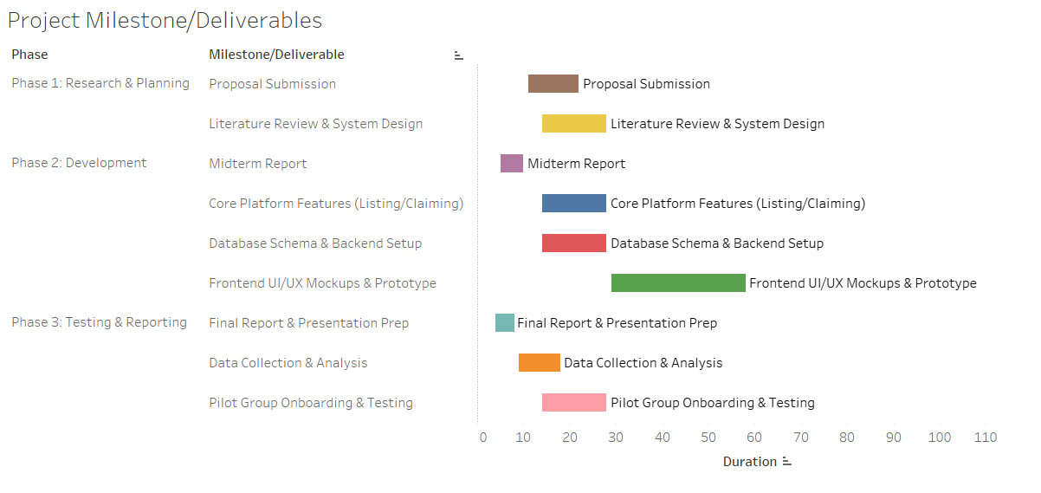

5.0 Project Contract
I, the undersigned, agree to the scope of work and timeline outlined in this proposal. I commit to dedicating the necessary time and effort to complete this project to the best of my abilities, adhering to the project plan, all academic integrity policies, and the detailed module list and data analysis plan.
Agreement: I agree to meet with the Professor during scheduled class hours and if necessary, once per week outside of class via video call to review progress against the milestones.
Signed
Frederick K. Okornoe

6.0 Work Logs for Student
Student Name: Frederick K. Okornoe
Date | Number of Hours | Description of work done
Sept 4, 2025 | 2.5 | Initial brainstorming and research for project ideas. Conducted preliminary research on food waste platforms and sharing economy models.
Sept 5, 2025 | 1.0 | Drafted the Project Proposal Title Page and Introduction sections (2.0-2.2).
Sept 8, 2025 | 2.0 | Outlined Proposed Research section, defining methodology and technology stack.
Sept 27, 2025 | 2.0 | Re-work of proposal document and brainstorming of a new idea. Created GitHub repo and checked in Progress Report 1 and Project proposal
Oct 4, 2025 | 2.0 | Reviewed submission feedback. Developed and added the detailed Core Application Modules (3.2) and the specific Data Analysis Plan (3.4). Updated the Project Timeline (4.0). Final review and formatting of the expanded proposal document for length and coherence.

7.0 Closing and References

7.1 Acknowledgements
I would like to thank Professor Bambang A.B. Sarif and my peers for their guidance and support throughout the planning phase of this research project.

7.2 References
- Food and Agriculture Organization of the United Nations. (2011). Global food losses and food waste - Extent, causes and prevention.
- Filieri, R., et al. (2020). The Role of Sharing Economy Platforms in Shaping Sustainable Consumption. Journal of Business Ethics, 162(2), .
- Lee, H., & Lee, J. (2018). A social perspective on food waste management. Journal of Cleaner Production, 180, .
- Belk, R. (2014). You are what you can access: Sharing and collaborative consumption online. Journal of Business Research, 67(8), .

spin-shift-russet-folk – database password

